CHAPTER 1
UNITS, PHYSICAL QUANTITIES, AND VECTORS
Discussion Questions
Q1.1 One correct experiment can disprove a theory, by showing that it doesn’t agree with the outcome of the experiment. Experiments, no matter how many, can never prove a theory to be true. There is always the possibility of the experiment which hasn’t been done yet that can show the theory to be wrong. But the more different experiments that agree with a theory, the more plausible and useful the theory is.

Q1.2 This is not possible. You can only take the tangent of an angle, and angles are dimensionless quantities. The tangent is the ratio of two lengths.

Q1.3 My height is 5 ft 6 in. This is 66 inches and equals (66 inches)(2.54 cm/1 in.) = 170 cm. My weight is 180 lbs. This is (180 lbs)(4.448 N/1 lb) = 800 N.

Q1.4 For selling tomatoes this rate of change is insignificant. In ten years the kilogram would increase in mass by 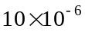 g = 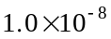 kg. The percentage change in mass is 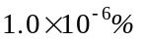. Scales used for ordinary commerce are much less accurate than this, so the change is not noticeable in these applications. But for very precise scientific work the change could be of significance.

Q1.5 There are many possibilities: the period between rising and setting of the sun, a person’s pulse, the time of fall of a rock dropped from a certain height, etc. Some time standards are better than others; a good time standard is stable over time, well defined, and easily reproducible.

Q1.6 Stack 100 sheets, measure the total thickness, and divide by 100.
Q1.7 Other examples are the tangent of an angle, the refractive index of a transparent material, the specific gravity of a liquid, etc.

Q1.8 The SI units of volume are m. The quantity 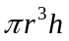 has dimensions of (length) so can’t be a volume.
Q1.9 Moe is precise but not accurate. Joe is accurate but not precise. Flo is accurate and precise. Precise means all arrows hit near to the same spot. Accurate means the arrows hit close to the center of the target.

Q1.10 If 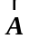 is a unit vector, 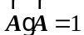. 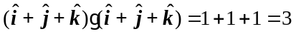, so 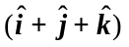 is not a unit vector. 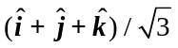 is a unit vector. , so 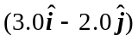is not a unit vector. 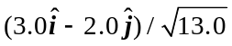 is a unit vector.
Q1.11 Displacement is the distance between the starting point and ending point. When the bicyclist has made a half-circle she is a distance 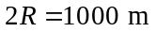from her starting point, so her displacement is 1000 m, south. When she has made one complete circle she is back to her starting point and her displacement is zero.

Q1.12 It is not possible for two vectors with different length to have a vector sum of zero. The vector sum has its smallest magnitude when the two vectors are antiparallel, and in that case the magnitude of the vector sum is the difference in the lengths of the two vectors, and this is zero only when the two vectors have the same length. If three vectors are to have a vector sum of zero the length of any one can’t be greater than the sum of the lengths of the other two.

Q1.13 Time is a scalar, not a vector. The elapsed time is always increasing and always positive and it is completely specified by a single number.

Q1.14 No, a vector includes both magnitude and direction. The instructions only specify direction.

Q1.15 No. The magnitudeof a vector is related to its components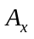and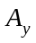by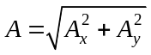. The only way to have 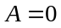 is for bothandto be zero. No. is greater than either 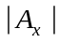or 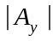.

Q1.16 (a) A vector has a positive magnitude and a direction. It does not make sense to say a vector is negative. (b)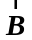is the negative of 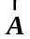 if 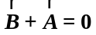. Also,is the negative of ifandhave the same magnitude and opposite directions. This doesn’t contradict what was said in part (a).

Q1.17 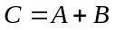 if and only if and are in the same direction. 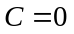if and only if either 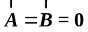 orand have the same magnitude and are opposite in direction.

Q1.18 No. 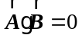only if andare perpendicular. 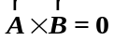only ifandare either parallel or antiparallel.

Q1.19 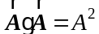, the square of the magnitude of . 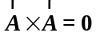.
Q1.20 The magnitude of 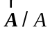 is 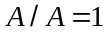, so is a unit vector. The magnitudeis positive, so has the direction of . 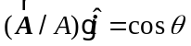.

Q1.21 The percent error is the error divided by the quantity. Therefore, the percent error is 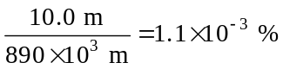. Since the distance from Berlin to Paris was given as 890 km, the total distance covered should be expressed as 890,000 m. We know the total distance to only two significant figures.

Q1.22 (a) Yes. and 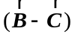) are each vectors; scalar product of two vectors is legitimate. (b) Yes. 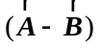and 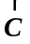are each vectors; vector product of two vectors is legitimate. (c) Yes. and 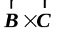 are each vectors; scalar product of two vectors is legitimate. (d) Yes. and are each vectors; vector product of two vectors is legitimate. (e) No. 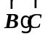is a scalar. The vector product of a vector with a scalar is not defined.
Q1.23 Not Equal: Let 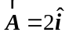, 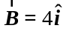and 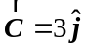. 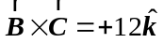and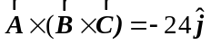. 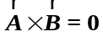 so 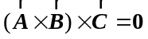.
Equal: Let 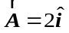, 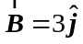 and 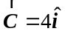. 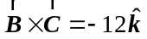 and 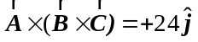. 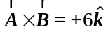 and 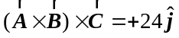.

Q1.24 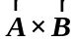is perpendicular to both and . If two vectors are perpendicular their scalar product is zero. Since is perpendicular to , 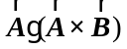is zero.

Q1.25 (a) No. 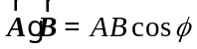. If 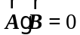 it could be that both A and B are nonzero but the angle between and is 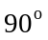. (b) No. 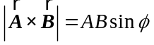. If 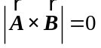it could be that both A and B are nonzero but the angle between and is either zero or 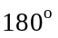.

Q1.26 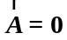says that . . The only way that A can be zero is for both and to be zero.

